From adversity, a Field of Dreams rises in Toms River
Stephen Edelson , @steveedelsonAPP Published 9:17 a.m. ET April 7, 2017 |
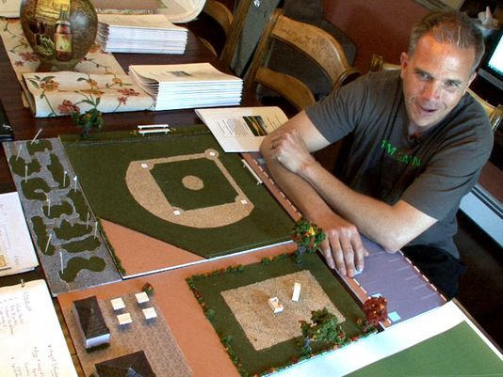Buy Photo
Christian Kane speaks about the “Field of Dreams” - a park where kids with disabilities can go to play - planned for Toms River during an interview Wednesday, March 5, 2017. His son Gavin, 6, has a severe brain trauma from a car accident five years ago. (Photo: Thomas P. Costello)

TOMS RIVER – There were nights Christian Kane was unable to sleep, the silence almost deafening as he lay in bed. It was too much like the absence of sound from the backseat, where his 19-month-old son, Gavin, was in a car seat, after a fully-loaded beer truck plowed into them from behind nearly five years ago. Or the initial hush on the other end of the phone when he called his wife, Mary, from Community Medical Center and told her there had been an accident.
Now, all the Kanes want to hear is the beautiful noise of children playing. The wonderful sound as special youngsters like Gavin, a 6-year-old still impacted by the severe brain trauma he sustained, experiencing joy of being a kid.
And that's why the Toms River Field of Dreams project is so important.
It is envisioned by parents who understand how important it is for those with special needs to have a place where they can feel normal, and it's become a crusade for a father with a background in athletics.
"Our older son, Owen, plays locally in baseball leagues and stuff," Christian Kane said, "and over the summer my wife and I looked at each other and said, 'Gavin is never going to be able to do anything like this.' So from there the whole thing kind of steamrolled."
Now there's a piece of land donated by the town, a realized business plan to raise $1.2 million from partnerships, grants and donations, and schematics that show a baseball field. The facility, which will host leagues, also features a playground, miniature golf course and picnic area. The key is it is all designed for youngsters with disabilities.
But there's much work left to be done for the dream to be realized.
The first major fundraiser will be in conjunction with the Lakewood BlueClaws on May 22 at FirstEnergy Park. They're also being handed the keys to Pine Belt Arena on the campus of Toms River North, where Christian Kane teaches math and used to be the head basketball coach, and are looking for a performer with a heart of gold to fill the venue and put them over the top.
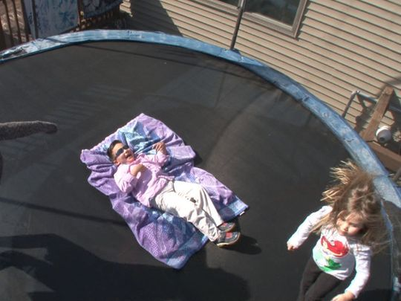Buy Photo
Gavin Kane, 6, who has severe brain trauma from a car accident five years ago, bounces on a trampolene with his cousin and sister at their Toms River home Wednesday, March 5, 2017. Gavin’s dad Christian is starting a huge fund raising movement to build what he calls a Field of Dreams in Toms River, where kids with disabilities can go to play. (Photo: Thomas P. Costello)
"It will be a field where every kid will be able to get a hit, score a run, play defense and hear the crowd cheering for them," Kane said. "And it's for every parent who thought their child would never experience that."
A place to call home
Christian Kane has made the right turn off Hooper Avenue onto Bay Avenue in Toms River hundreds of times since that day. But instead of taking the shortcut, the left-hand turn off Bey Lea Road. into Toms River North's back entrance, he goes up to the light and makes a left onto Old Freehold Road, and goes through the front entrance.
"I go by there every single day," he said. "How do you not forget?"
It was while waiting to make the left-handed turn he now bypasses that the accident happened on July 12, 2012. Kane was heading to the school to write curriculum during the summer months.
The ambulance was there within minutes. Gavin was flown from Community to Jersey Shore University Medical Center, where he spent a month, before another month at Children's Hospital at Robert Wood Johnson University Hospital.

"The first devastating thing was being told that he might not make it. You can't ever imagine what that feels like to be told that," recalled Mary Kane, who stayed with Gavin at the hospitals even though she was five months pregnant with their sixth child at the time of the accident.
"There are certain things I specifically remember, like that he is fighting for his life and he may not make it and the next 48 hours are crucial. And then when we were told he had brain damage. Because you hear that and you're like, 'Wow,' but you really don't know what you're in for. No one ever tells you the extent."
The Kanes were also shown pamphlets for care facilities where Gavin could live. At which point they looked at each other and then made it clear that their son would be coming home with them. So they bought a house down the street and turned it into a place where their son could live the rest of his life if he chooses to.
Now it's incredibly uplifting to see the infectious smile on Gavin's face even as he's struggling to move his legs to propel the "stander," a specially designed wheelchair that places him in an upright position, across the floor inside the home the Kanes have overhauled to make handicapped accessible.
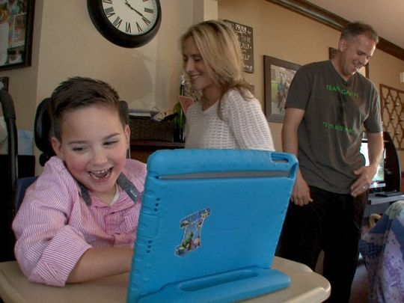Buy Photo
Gavin Kane, 6, tells a joke through his iPad and cracks up his parents Christian and Mary at their Toms River home Wednesday, March 5, 2017. Gavin has a severe brain trauma from a car accident five years ago. Christian is starting a huge fund raising movement to build what he calls a Field of Dreams in Toms River, where kids with disabilities can go to play. (Photo: Thomas P. Costello)

He's in kindergarten at Silver Bay Elementary School, and speaks through a tablet computer, his right hand navigating the touch screen.
"He knows what is going on. He's just trapped inside his body," Christian Kane said. "He knows to have a conversation with you. He knows how to count. He knows how to read. His problem is that the brain is just not connecting with his body. The brain doesn't know what to do with his legs or his hands or his arms. But he is getting better."
And while the Kanes have built a small play area in their backyard for Gavin, complete with a rubberized surface and a trampoline, not everyone has access to special needs-friendly facilities.
"During the week there's school and therapies. The problem is when it's summertime and the weekend," Christian Kane said. "Parents need a break. And it would be nice for mom and dad to be able to pull into the parking lot and have two volunteers from the Toms River school district, maybe high school kids working on their 50 hours of community service, meet them at the car to help."
Build it and they will come
Having played high school basketball and baseball under legendary coach Jack Curran at Archbishop Molloy in New York City – he played basketball alongside Kenny Anderson – Christian Kane learned invaluable lessons that continue to resonate. He went on to play baseball at Monmouth University under Walt Woods, and was an assistant basketball coach at CBA for 15 seasons under Ed Wicelinski, coaching players like Robert Morris coach Andy Toole along the way.

His own life saved, Gerry Cooney eyes a rebirth for boxing

"You can look at this from a coaching perspective," he said. "You're in the first quarter and you're down 15 points, or you just gave up runs in the bottom of the second. We're losing, but what are you going to do? Give up? No. You're going to put some runs together and figure it out from there. There is no game plan. You adapt and adjust. What happened to Gavin is not a death sentence."
The new game plan is the Field of Dreams, which is for special needs children from anywhere, not just Toms River.
The Kanes have already gotten a grant from the Cal Ripken Sr. Foundation to help with the cost of building the actual field. Alexandra's Playground has made a major donation for the construction of the playground and they've gotten a grant from the Philadelphia Phillies, while local businesses have pledged their support.
But a lot more money must be raised before construction can begin.
For the May 22 fundraiser at the Lakewood BlueClaws game, they are trying to sell a minimum of 500 tickets at $20 a ticket, which includes a Field of Dreams T-Shirt. Four luxury suites have also been donated for that game and those tickets are $75, which includes food, non-alcoholic beverages and a T-Shirt.
For tickets and more information on Field of Dreams, contact Christian Kane directly at (732) 998-3667, or by email at greatdad37@yahoo.com.
The Kanes also have the use of Pine Belt Arena, the 3,200 seat venue in Toms River, for a weekend, free of charge. And if they can find a big-name act or entertainer to perform for free, or at a discount, it might be the last piece of the puzzle.
"This is so important because there are no facilities like this," Christian Kane said. "We go to a public park and we have to wait for a kid who is normal to get off the special needs-assisted swing so that Gavin can finally get on. That's the idea. The idea is to build a place, a field of dreams, for kids to come, and be able to do things that they normally wouldn't be able to do."
Field of Dreams will fill a vital need in the area. And what's clear to everyone is that if you build it, some beautiful, deserving kids will come.
Staff writer Stephen Edelson is an Asbury Park Press columnist. Email: sedelson@gannettnj.com
16 CONNECTTWEETLINKEDINCOMMENTEMAILMORE
TOP VIDEOS

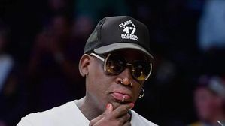
Dennis Rodman rips on LeBron James, again
1:38

Yadier Molina's magical baseball incident
1:15

Who should win NBA MVP?
1:19

Who is Charley Hoffman?
1:19

A blustery first day at the Masters
1:25

Tim Tebow homers in first minor league at-bat
0:39

Tim Tebow's journey to minor league baseball
0:59

Dustin Johnson withdraws from Masters
0:46

RAW: Rutgers WR-KR Janarion Grant warms up before practice
0:27

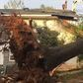
First Round of Severe Storms Hits Southeast
1:08

Philadelphia Phillies
BlueClaws: Lakewood unveils 2017 roster, opens season in Kannapolis
Chris Rotolo

College baseball: The Jersey aces of tobacco road
Jerry Carino
Help wanted: Lakewood BlueClaws looking for catchers
Stephen Edelson

Charlie Manuel, Larry Bowa remember Dallas Green
Meghan Montemurro

Asbury Park Press Dollar Days return to BlueClaws
Steve Feitl
2017 Spring Training: Yankees vs. Phillies
by Taboolaby Taboola
Sponsored LinksSponsored Links
Promoted LinksPromoted Links
AD CONTENT

Vikings: Free Online Game
If you own a computer you must try this strategy game!Vikings: Free Online Game
Undo

College Freakz
'Charlie's Angels' Actress Jaclyn Smith Is Totally Unrecognizable TodayCollege Freakz
Undo

Ancestry
Do You Know What Your Last Name Means?Ancestry
Undo

Nerdwallet | Munchery
Munchery is the Meal Kit Taking Out the Biggest Time-Drain--Cooking!Nerdwallet | Munchery
Undo

HowStuffWorks
Men, Can You Ace Our Repairing a Small Engine Quiz?HowStuffWorks
Undo

The Weekly Brief | Mack Weldon
Here’s Why Guys Are Obsessed With This Underwear…The Weekly Brief | Mack Weldon
Undo
Sponsored LinksSponsored Links
Promoted LinksPromoted Links
MORE STORIES

Sullivan: They can take Hurley's school, but they can't take his legacy
Sports
| 45 hours ago
Undo

Monmouth would rather drop to Division III than pay athletes
Sports
| 29 hours ago
Undo

Softball: Howard sets Lacey record; Roncin continues hot start for Donovan Catholic
Sports
| 38 hours ago
Undo

Softball: Donovan Catholic, Middletown North lead 2017 pre-season Top 10
Sports
| 6 days ago
Undo

sports
Monmouth would rather drop to Division III than pay athletes

Close
Get the news
Log In or Subscribe to skip
Already a subscriber?
Log in
Subscribe today for full access on your desktop, tablet, and mobile device.
Subscribe Now
Already a subscriber, but don't have a login?
Activate your digital access.
MORE NEWS
sports
High School
College
Pro Sports
Fishing/Boating
Red Zone
USAToday Sports
Sports
From adversity, a Field of Dreams rises in Toms River
Read StoryStephen Edelson@steveedelsonAPP
